Using the Informal SI Controls and Printer

Overview

The combined two kits comprise
36 normal controls numbered 106 to 131, 031 to 040
3 Start controls
3 Finish controls
1 Clear control
1 Check control
2 Blue SI-Master units (SIM) (Labelled SI-Master and CLEAR) This can also be used as a CLEAR station if needed.
2 Special dibber Service /Off
2 Special dibber Clear Backup
2 Special dibber Print Results
1 Special dibber Start
49 Hire Dibber (222020 lost)
5 Control placing check dibbers
2 Programming Stick
2 Printer Download unit (Yellow Stripe)
2 Thermal Printer
2 Mains Chargers for the Printers
1 Car Charger for the Printer
2 Printer cables
2 Computer link cables (not normally used)
Spare Paper rolls (Inform Alan Hooper if low)
44 Plastic Stakes

The kit is kept in three plastic boxs. These controls are of a new design and are always ON, the only action needed is to synchronise their internal clocks before the event using the SIM unit.

You will also need the WSX standard Informal Kit box together with a set of control kites.

Before the Event/ Previous night
Charge the printer by plugging its power adaptor into the mains and the Jack Plug into the hole on the front of the printer. The printer Green LED lamp will flash every 3 seconds to indicate charging and will go steady when fully charged. This will take about 4 to 6 hours if batteries are flat but the printer can be left plugged in overnight without damage, it will switch to a trickle charge when complete. A problem that can occur is that if the printer battery is well discharged before charging then the charging process may stop much too soon, maybe before one hour. To avoid this it is best to allow the unit to charge for say half an hour, then switch it off from the mains, wait a few seconds and then switch the charger back on and leave on. A fully charged battery will print around 50 printouts which may be OK for an informal, it is best to plug in the car charger when on site which should keep it going indefinitely.

Check that you have all the controls needed for the event.

Check the SIM time by using the Purple coloured “Service Off” dibber contained in the printer box. Repeated brief insertion of this into the SIM will cause the LCD display on the top of the SIM to automatically cycle through the states CLR 1, TIMEMAS, EXT MA , OFF Switch the mode to TIMEMAS = Timemaster, this mode works only with the new small controls and just resets the time but does not clear the internal memory of previous competitors which should be done using the CLEAR MEM purple dibber. If using a mix of new and old controls the old controls should be synchronised using the TIMEMAS mode since extended mode as above doesn’t work with these. The old controls memory will have been cleared when they were programmed on a PC.

TIMEMASTER mode just cycles through TIMEMA and the time. We no longer use the Extended Master mode since this is rather slow, it is much faster to clear old records using the CLEAR MEM purple dibber.

Check that the time displayed is reasonably close to actual time, exact agreement doesn’t matter since this is the “race time” that will be used, the only problem if it is wrong is that competitors may query the printouts in comparison with their watches, splits and elapsed run time are of course accurate. If the SIM needs to be reset then take it to Alan Hooper for re-setting, it is supposed to be as good as a wrist watch in maintaining time.

Setting out controls on the day
- The stakes do not have any numbers so can be placed anywhere, the control boxes have large enough numbers to be seen by the competitors.

- Before distributing the boxes to the control placing team they must be memory cleared and then synchronised. This is done using the Blue SIM Unit. It is assumed that the time in the SIM is accurate enough for the event, (see above). Use the following procedure.

Group all the control boxes together, including start, finish ,clear and check boxes. Clear the old results in memory using the CLEAR MEM purple dibber. NOTE that if a box issues a sequence of 4 sequential beeps then its battery is getting low and need to be returned to A.Hooper for replacement.
Switch the SIM into TIMEMAS mode as above.
Insert the thick end of the black programming stick into the SIM. See the pictures on the next page for physical positioning.
Place the thin end of the stick into each new style control and hold it there until you hear a twin bleep. The stick needs to protrude right through the control being synchronised. This may take tens of seconds so don’t be impatient.
If old style boxes are also used these must first be turned on with a magnet and then synchronised using the SIM set to TIMEMA mode.
IMPORTANT::: We have found that it is easy to think that a control has been synchronised but, in fact, it hasn’t. Therefore check all the controls BEFORE placing out in the forest. Inset a cleared normal dibber into each box to check operation then print out the dibber to check all is working OK looking for any times out of sequence. If found, re-synchronise the offending control boxes. Also listen out for low battery warning as above.

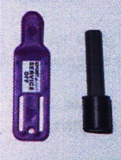
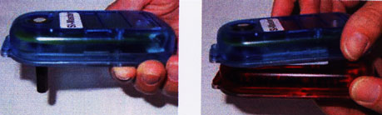

The SIM with programming stick inserted
The correct way of doing the actual syncronisation
One of the Special Dibbers and a programming stick

The Printer

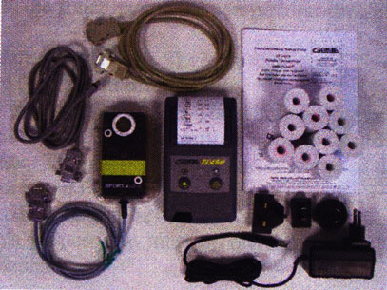

Synchronise the Printer Download box using the SIM in Extended mode. Failure to do this may result in some printout times having 12 hours added to them.

This is entirely automatic and switches itself ON when a dibber is downloaded. To connect the Download box use the cable with a 9W D socket on one end and a small printer connector on the other. The download box is always ON and will power up automatically. See the earlier remarks about charging the printer, best to use a car charger at the finish to ensure long battery life, especially if you are expecting more than 50 people.

After printing the test dibbers use the “Clear Backup” purple dibber to clear out the old competitors stored in the download box memory.

Downloads of competitors dibbers will give splits, accumulated and total run times on a customised Wessex ticket. If you want to customise the ticket for advertising purposes (e.g. future events?) contact Alan Hooper before the event.

After the event (or during it if desired) use the “Print Results” purple dibber to print out a list of everything in the download box memory. It just lists dibber numbers and total run times.

Please return all equipment to the storage box provided in a clean condition.

A.Hooper

